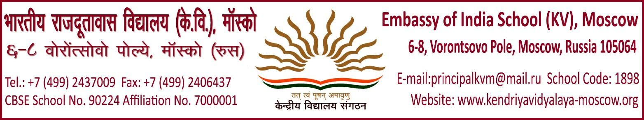
PROVISIONAL ADMISSION- OPTION FORM
FOR CLASS XI 2022-23

- Name of the student

- Name of the Father

- Name of the Mother

- Total Marks and percentage obtained in AISSE 2022
MARKS OBTAINED: PERCENTAGE:

- Category: KVS/EOI/IC/FC____________________________
SELECT AND TICK ONE : SCIENCE / COMMERCE
- Choice of stream in class XI
Please tick and write opted stream _________________________________
English(core),Maths, Physics,Chemistry&Comp.Sc
English(core) Maths, Physics, Chemistry & Economics
English(core) Maths, Physics,Chemistry Hindi(core)
English(core) Maths, Physics, Chemistry, &Biology,
English(core),Biology, Physics, Chemistry, & IP
- Subject combination(SCIENCE)
Please tick and write one subject combination from the box above: _____________________________________
OR
- Subject Combination(Commerce)
Please tick and write one subject combination from the box above: ________________________________________
English(core),Accountancy,B.st Economics & IP
English(core)Accountancy, B.st.Eco&Maths,
- Admission No.
- Contact address/Mail ID
Certified that all the particulars filled in in the form are correct. I do not claim the change of subjects in future.

Signature of the Father/Mother PRINCIPAL

